Virtual Catalytic Reactor Laboratory

John L. Falconer and Neil Hendren

Department of Chemical and Biological Engineering

University of Colorado Boulder

Boulder, CO 80309-0596

September 30, 2020

 The text will be double-spaced in final version . Check word limit for abstract.

**ABSTRACT**

A virtual catalytic reactor laboratory (VCRL) experiment, which can be used in most browsers, is described. Students select feed conditions and use the VCRL to take data for a gas-phase catalytic reaction and fit kinetic parameters to a Langmuir-Hinshelwood rate expression. The VCRL contains instructions, equipment descriptions, an animated start-up procedure, a video tour of a physical laboratory, screencasts about nonlinear regression, a means to submit answers online, and an instructor portal.

**INTRODUCTION**

A virtual catalytic reactor laboratory (VCRL) experiment was prepared to be used as a replacement for or complement to a physical laboratory (PL) or as a longer assignment/project for a kinetics/reaction engineering course. This VCRL can be used in modern web browsers and is available at <https://virtual-labs.learncheme.com/catalytic-reactor/>. The VCRL aims to imitate a hands-on PL for a gas-phase, catalytic reaction (A + B → 2C). Students can vary the pressure and molar feed flow rates of the reactants, and the VCRL displays the corresponding effluent composition. The aim is for students to use nonlinear regression to obtain kinetic parameters for a Langmuir-Hinshelwood rate expression.

The VCRL interface is an interactive equipment diagram that mimics a laboratory-scale catalytic reactor experiment. Students can left-click on mass flow controllers (MFCs) and a pressure controller to adjust reactor inlet conditions, or right click on various pieces of equipment to display an article describing its function. Documentation describes how to collect data and perform nonlinear regression. The documentation also includes post-lab questions, learning goals, relevant assumptions, and a video of a physical catalytic reactor. Students are allocated a fixed amount of funds and each experimental run uses some of those funds. Students, as individuals or as part of a group, create a login so they can save their data, which may be downloaded as a spreadsheet. Each student or group has a different set of randomized kinetic parameters. Instructors have a portal where they may view their students’ kinetic parameters and answer submissions.

**Comparison of virtual and physical laboratories**

Some advantages that virtual laboratories (VLs) have over PLs include:

* Availability at any time and location. Students can analyze initial results and then plan additional experiments that can be run over multiple days; PLs are location and time-limited [1].
* The ability to run experiments that are too time-consuming for a PL [2, 3]. For example, procedures that take a few seconds in a VL (furnace reaching a desired temperature, a reactor reaching steady state, a gas chromatograph (GC) analysis) would each take many minutes in a PL. Students can repeat an experiment more easily [13].
* Cost-effectiveness since VLs are less expensive than PLs and easier to maintain.
* The ability to be updated based on feedback, allowing for continuous improvement.
* The ability to make abstract phenomena more visible [13].
* Safety. VLs can expose students to hazardous techniques not available otherwise [2], and different conditions can be tried without the risk of damaging equipment.

Because PLs have constraints (safety, logistic, material), instructors often provide directed procedures that limit student’s construction of experimental procedures, some PLs may not achieve their learning objectives, [12].

Thus, studies have argued that VLs can adequately replace PLs [5, 14]; VLs allow students to use inquiry practices that might be difficult in PLs [14]. Indeed, studies have found VLs are effective at increasing student learning, and studies reported conceptual understanding from VLs was at least as good as from PLs; in contrast, some studies concluded that PLs are better, whereas others found no difference [3, 5, 7, 13]. Hernandez-de-Menendez et al. [7] claimed that the main advantages of VLs are safety, flexibility (students can perform experiments at any time), and greater diversity of equipment that can be used. They] claimed that VLs can replace PLs because students have time to complete activities that support deeper learning. They claimed the main disadvantage of VLs is that socialization is not possible [7]. Cooperative learning can improve content achievement and communication skills. Corter et al. [6] concluded that learning outcomes are roughly equivalent no matter the format. They stated that the majority of comparative studies concluded that VLs are a good substitute for PLs in teaching concepts and their applications, and the design of the simulation is responsible for the learning differences reported in different studies. The quality of the VLs differ significantly between studies. Studies suggest tactile information is not needed to develop conceptual knowledge [14]. Instead, manipulation, not physicality, may be important for instruction [13]. The Physics Education Technology (PhET) project reported that students had a strong preference for VLs over PLs [8]. They found that students could visualize complex phenomena and test their understanding of scientific concepts more easily than with PLs because students were not merely attempting to replicate an expected result.

Comparative studies have been conducted over a wide range of disciplines. Physics VLs and PLs were found to be equally effective at promoting understanding of concepts, and better than instruction without any laboratory [4]. In a biology course, fewer students received D's or F's after using VLs [2]. Finkelstein et al. [9] found that circuits VLs can be more effective than PLs. Students who used a simulation built a real circuit faster than students who used a PL, and those students performed 12 percentage points better on the exam. In contrast, Alfred et al. [1] reported identical cognitive outcomes for PLs and VLs in a circuits laboratory, but students who used a PL could subsequently construct circuits faster. Holmes and Wieman [10] showed that physics PLs made no difference in performance on final exam questions; they attributed this to the lack of decision making by students in the labs. Learning objectives of PLs can often be met by VLs alone or by using hybrid approaches [7, 11].

**OVERVIEW OF VIRTUAL CATALYTIC REACTOR LABORATORY**

The virtual catalytic reactor laboratory (VCRL) models an exothermic, gas-phase, catalytic reaction (A + B --> 2C) in an isothermal, packed bed reactor. Pressure drop is assumed to be small across the reactor, which is modeled as a plug flow reactor. The goal is to determine the values of k, KA, and KB and their 95% confidence limits for the Langmuir-Hinshelwood rate expression:

$$r=\frac{kP_{A}P_{B}}{{\left(1+K_{A}P_{A}+K_{B}P_{B}\right)}^{2}}$$

where PA and PB are the partial pressures of A and B, k is the rate constant, and KA and KB are adsorption equilibrium constants. The VCRL home page displays an overview, prerequisites, and the following learning objectives:

* Explain the function of each part of the catalytic reactor system
* Understand how flow rates into a packed-bed reactor (PBR) affect reactant conversion
* Understand the effect of pressure on the rate of a gas-phase reaction
* Efficiently select reaction conditions for PBR measurements
* Explain the reasons experimental conditions were chosen
* Apply nonlinear regression to determine kinetic parameters and their 95% confidence intervals
* Answer questions about catalytic reactor behavior.

The instructors’ portal contains additional information on the laboratory procedure, typical results, access their students’ data (including the kinetic parameters assigned to each student (or group) and their answer submissions, and an option to run the simulation from a student's perspective. Instructors can request an account by emailing [LearnChemE@gmail.com](mailto:LearnChemE@gmail.com).

The student login page contains documentation (Figure 1) that explains how to get started, how to analyze data, and how to submit kinetic parameters (and confidence intervals) upon completing the lab. Students can log onto the VCRL under an instructor's name as an individual or as part of a group; they choose a password when they first log on. The simulation stores students’ data so experiments can be performed over multiple sessions.

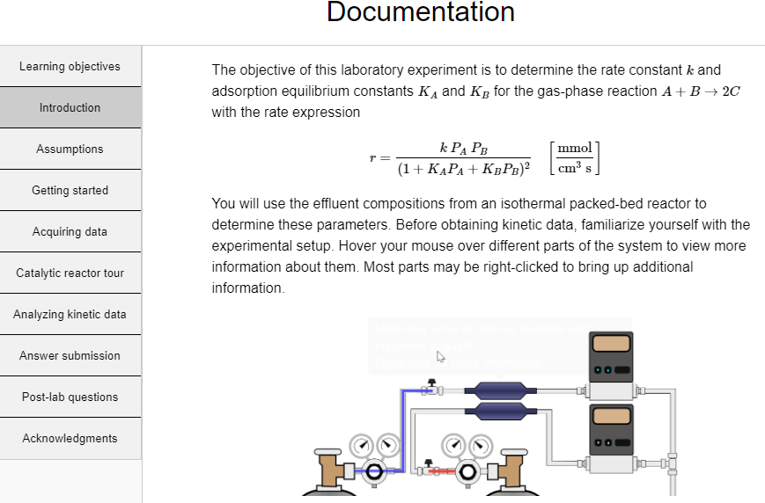

*Figure 1. Documentation page that introduces the VCRL and provides resources for using it. Links to resources are on the left.*

When a student or group creates an account, the VCRL selects a random temperature and kinetic parameters; each student or group has different parameters. Individual students or groups are allocated $10,000, and each experimental run costs $250. Instructors can base part of the student grade on the funds remaining in their account. Each time a student logs in, the reactor system in Figure 2 is displayed. Students must start up the equipment by clicking “start up reactor”; this costs $125. Clicking “start up reactor”:

* Opens the feed gas valves and close the reactor bypass valve
* Increases the sand heater temperature to the desired value
* Turns on and calibrate the GC
* Allows the system to reach steady state

All aspects of the start-up are much faster than in a PL in order to save time.

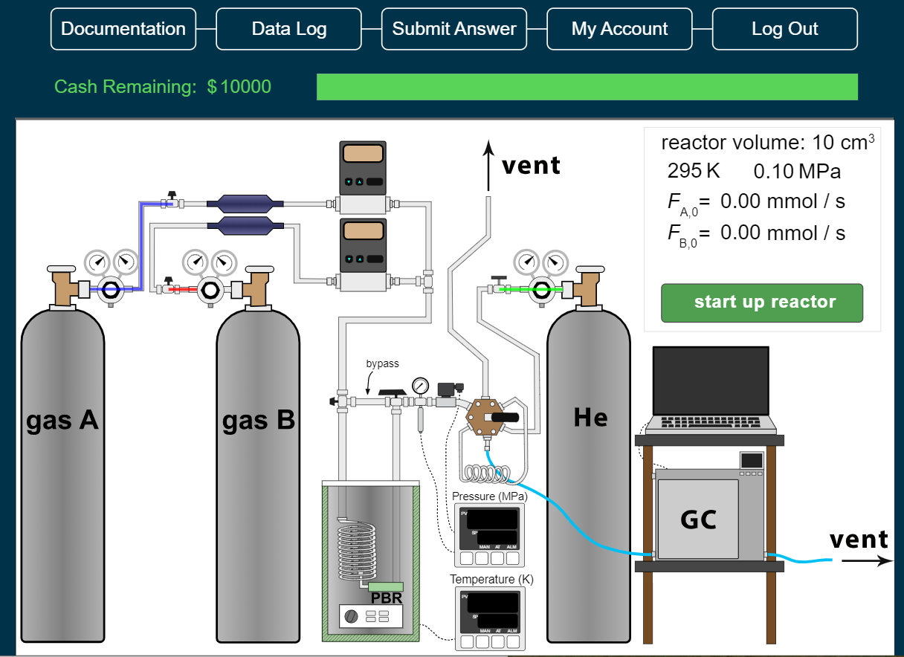

*Figure 2. Main page in VCRL before start up. The valves after the regulator are closed (the red, blue, and green colors indicate sections of the lines that contain gas), the sand batch heater is at room temperature, and the GC is turned off.*

**RUNNING THE VCRL**

Figure 3 shows the VCRL after startup. Tooltips appear when a mouse pointer hovers over a piece of equipment; right-clicking the equipment opens a link with more information. Not all equipment is not drawn to scale; e.g., the sample loop volume is exaggerated so it is easier to see. A typical sample volume in a PL is 1 cm3. To take a measurement, students adjust the MFCs and pressure controller by left-clicking on them and typing a desired value into the input box. The then click the multi-selector valve to push the sample to the gas chromatograph (GC), and -click the GC to view the effluent composition. They then click the multi-selector valve again to collect a new sample. Students should plan their experiments since the molar flow rates of A and B and the reactor pressure all affect effluent molar flow rates. Operating the VCRL is similar in many ways to operating a corresponding PL. In a PL, the furnace temperature, the pressure, and the MFC values are set on a computer, the multi-selector valve is computer controlled, and the GC results are analyzed by a computer.

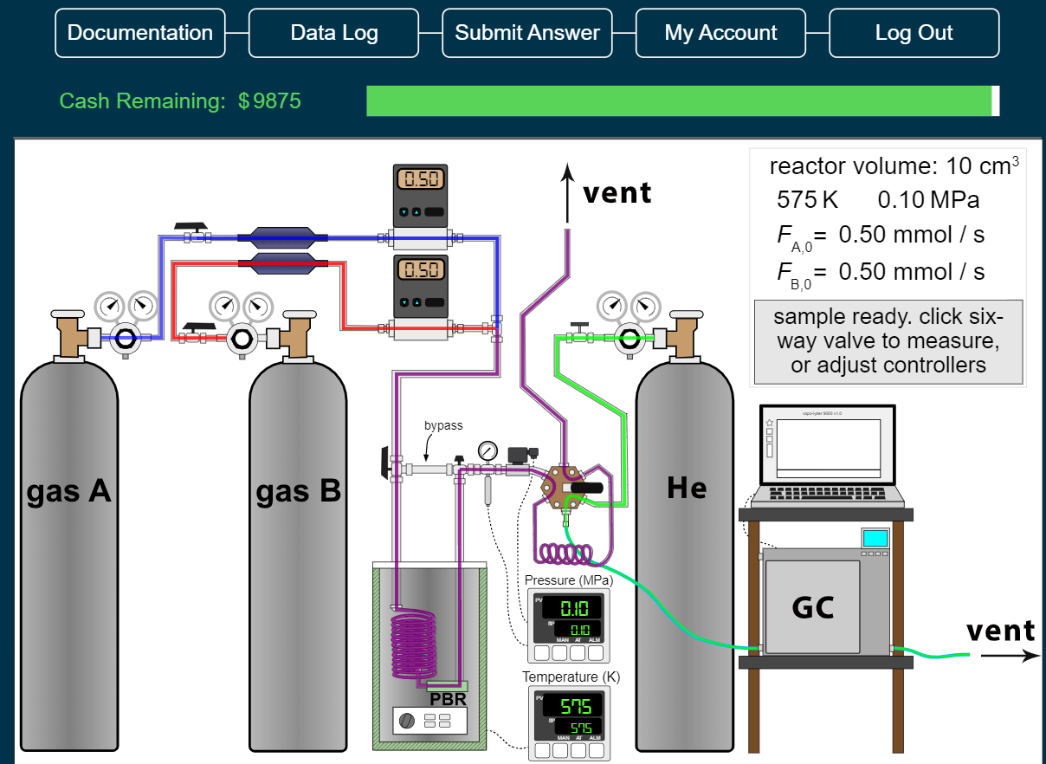

*Figure 3. Main page in VCRL after the system has started up. The gas mixture flowing through the reactor is purple, and the reactor effluent flows through the sampling loop.*

When a MFC flow rate is changed, the VCRL briefly displays the statement "reaching steady state". Red and blue lines represent the feed gases, which mix to form a purple gas that then passes through the preheater coil, the reactor, and the sampling loop before exhausting to the vent. When the multi-selector valve is toggled by left-clicking it, an animation shows the reactor effluent traveling into the GC and the green helium carrier gas flowing through the sample loop. A representative chromatograph is displayed on the computer above the GC. Students must left-click the multi-selector valve again to move it back to the sampling position to collect the next sample. Data may be downloaded as a comma-separated values (CSV) file that can be opened using a spreadsheet.

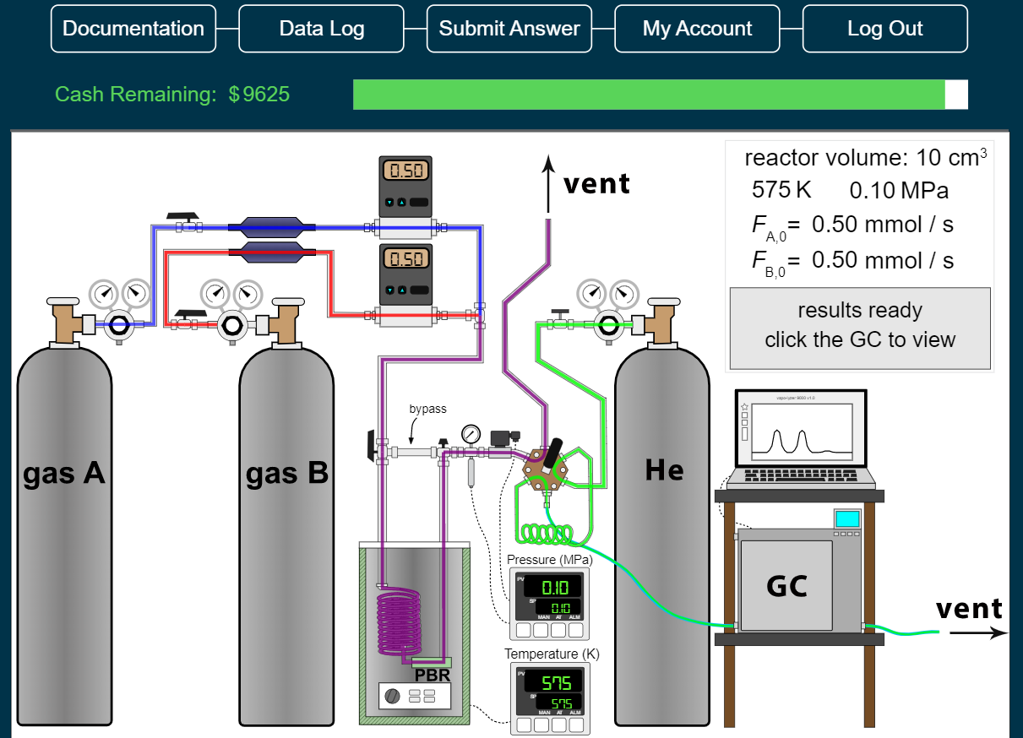

*Figure 4. Main page in VCRL after injecting gas in the sample loop into the GC. The reactor effluent flows to a vent. The green gas line is helium flowing through the GC.*

Students can work in groups with each student logged onto the VCRL at the same time; they each can run experiments independently and within a few seconds the data will show up on the data log for the other students to see. Alternatively, one student can log on and share his/her screen with group members using conferencing software (Zoom, Google Meet, GoToMeeting). They can then jointly plan experiments. This is similar to many PLs where one student makes changes in the equipment and others record data, make suggestions, and discuss the results.

**DATA ANALYSIS**

Three screencasts in the documentation explain Langmuir-Hinshelwood kinetics, nonlinear regression, and the approach used to analyze data from a PBR. Four more screencasts demonstrate the use of nonlinear regression in Excel spreadsheets to analyze kinetic data. The Excel spreadsheets are available at <http://www.learncheme.com/student-resources/excel-files>. The spreadsheets solve the differential-equation mass balances numerically and apply nonlinear regression to the parameters used in the mass balances.

**ACKNOWLEDGMENTS**

We appreciate financial support from Chevron, the University of Colorado Engineering Excellence Fund, and the Department of Chemical and Biological Engineering. We also appreciate valuable feedback and suggestions from Dr. Scott Rowe, Professor J. Will Medlin, Professor Stephanie Wettstein, Professor David L. Silverstein, Professor Milo D. Koretsky, Professor Margot Vigeant, Mathew Rasmussen, Zachary Blanchetter, and Laura Paz. The nonlinear regression spreadsheets were developed with extensive assistance from Professor David E. Clough. We thank Mathew Rasmussen for making the video of a research laboratory catalytic reactor. The screencasts were processed by Michelle Medlin.

**REFERENCES**

1. Alfred M, Neyens DM, and Gramopadhye AK (2018) Comparing learning outcomes in physical and simulated learning environments. Inter. J. Ergonomics 68: 110-117.

2. Raineri D (2001) Virtual laboratories enhance traditional undergraduate biology laboratories. Biochem. Mol. Biol. Educ., 29(4): 160-162.

3. Sharma S and Ahluwalia PK (2018) Can virtual labs become a new normal? A case study of Millikan's oil drop experiment, Eur. J. Physics, 39, 065804: 1-18. DOI: 10.1088/1361-6404/aada39

4. Zacharia ZC and Olympiou G (2011) Physical versus virtual manipulative experimentation in physics learning. Learn. Instruct. 21(3): 317-331.

5. Altalbe AA (2019) Performance Impact of Simulation-Based Virtual Laboratory on Engineering Students: A Case Study of Australia Virtual System, IEEE ACCESS 7: 177387-177396.

6. Corter JE, Esche SK, Chassapis C, Ma J, and Nickeson JV (2011) Process and learning outcomes from remotely-operated, simulated, and handson student laboratories. Comput. Educ. 57(3): 2054-2067.

7. Hernandez-de-Menendez M, Guevara AV, and Morales-Menendez R (2019) Virtual reality laboratories: a review of experiences. Inter. J. Inter. Design Manufacturing - IJIDEM 13(3): 947-966.

8. Wieman CE, Adams WK, and Perkins KK (2008) PhET: Simulations That Enhance Learning. Science 322(5902): 682–683.

9. Finkelstein ND, Adams WK, Keller CJ, Kohl PB, Perkins KK, Podolefsky NS, Reid S, and LeMaster R (2005), When learning about the real world is better done virtually: A study of substituting computer simulations for laboratory equipment, Phys. Rev. ST-Phys. Educ. Res. 1: 010103-1 – 0101103-8.

10. Holmes NG and Wieman CE (2018) Introductory physics labs: We can do better. Physics Today 71(1): 38-45.

11. Feisel LD and Rosa AJ (2005) The Role of the Laboratory in Undergraduate Engineering Education. J. Engin. Ed. 94(1): 121-130.

12. Nolen SB and Koretsky MD (2018) Affordances of Virtual and Physical Laboratory Projects for Instructional Design: Impacts on Student Engagement. IEEE Trans. Ed. 61(3): 226-233.

13. Zacharia Z (2007) Comparing and combining real and virtual experimentation: An effort to enhance students’ conceptual understanding of electrical circuits. J, Comp. Assist. Learning, 23(2): 120-132.

14. de Jong T, Linn MC and Zacharia ZC (2013), Physical and virtual laboratories in science and engineering education, Science 340(6130): 305–308.